



Case Study – Section Data Science & Analytics

**Python – Advance Level**

# Introduction

**ABC Global Media Entertainment Company** develops and maintains repository of all global movies with an [online database](https://en.wikipedia.org/wiki/Online_database) of information related to world films, television programs, home videos and video games, and internet streams, including cast, production crew, personnel and fictional character biographies, plot summaries, trivia, and fan reviews and ratings.

Aligned to its objective of becoming a highly competitive with maximum advertisement visited site, ABC has requested for new initiative to be implemented

# Background and Objectives

Company already has a portal to collect world-wide information but it is missing analytics and data visualization module

## Movies database





## Requirements

You are being assigned a task to analyze current movie database attributes and provide different data visualizations using matplotlib or any other data visualization libraries of Python

1. Line Plot/Date Handling – Total number of movies per year
2. Bar Chart- Total US Revenue and Overseas Revenue per year side –by side

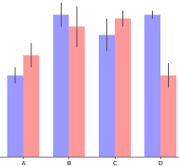

1. Scatter Plots – Size by gross revenue and rating

